Module 1: Critical Thinking

Bryan Moffett
Colorado State University Global
ITS410: Database Management
Dr. Raquel Hicks
August 23rd, 2026

Create MySQL Database
Task 2.3 - my_guitar_shop.sql Execution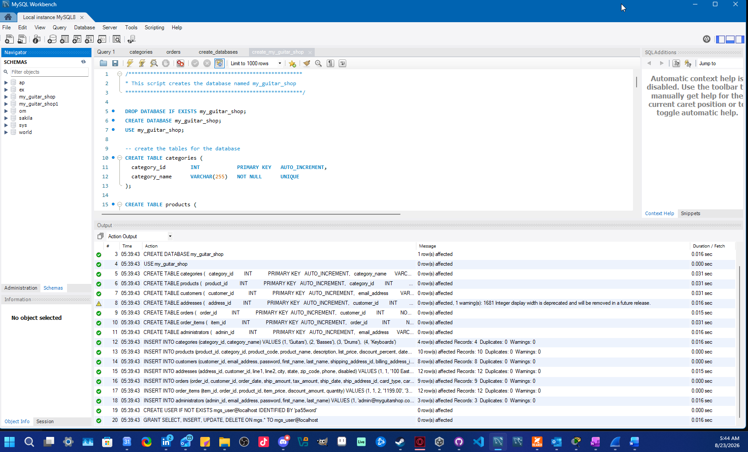
Task 3.3 - SELECT product_name FROM products;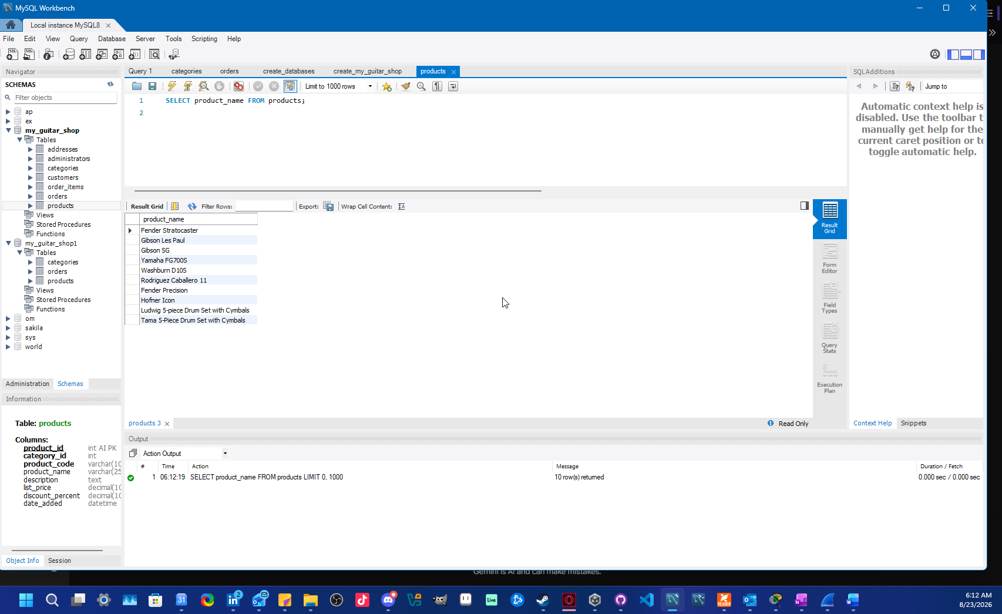
Task 3.5 - Error Code: 1054. Unknown column 'product_nam' in 'field list'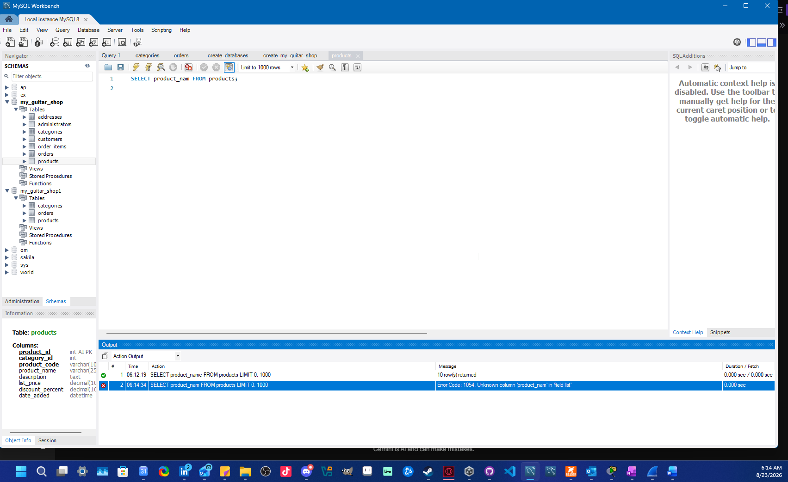
Task 4.2 - product_details.sql Execution
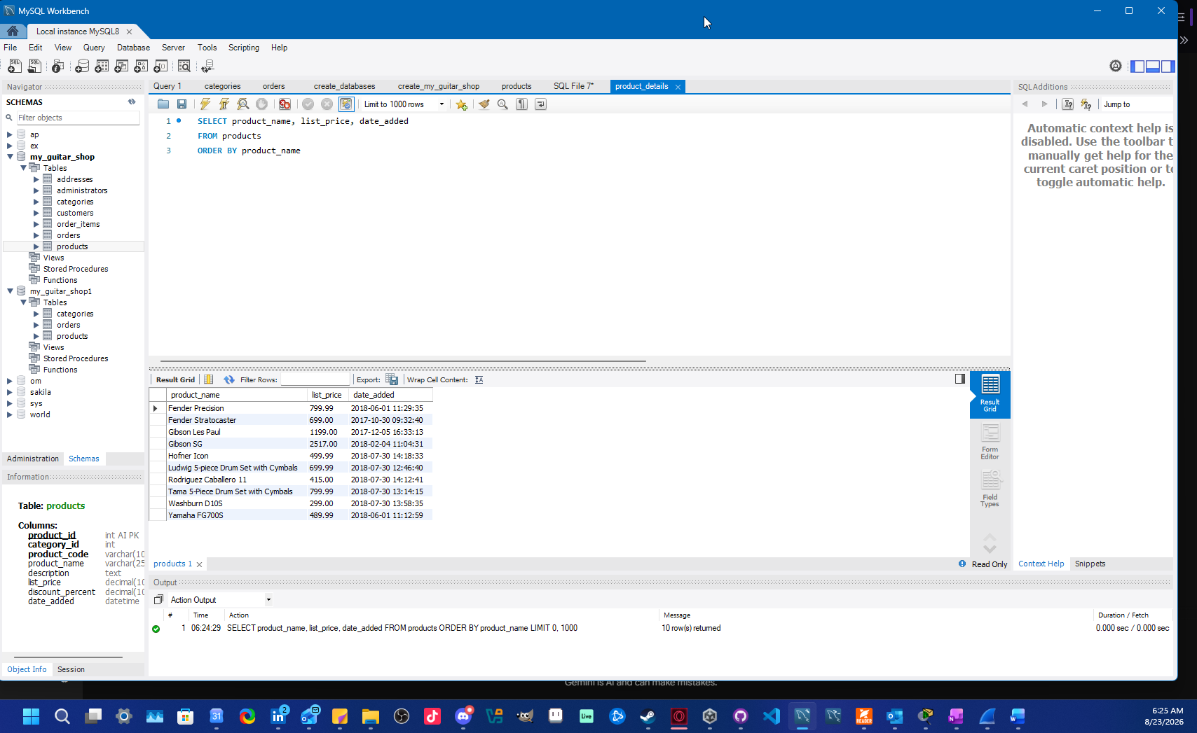
Task 4.4 - product_summary.sql Execution
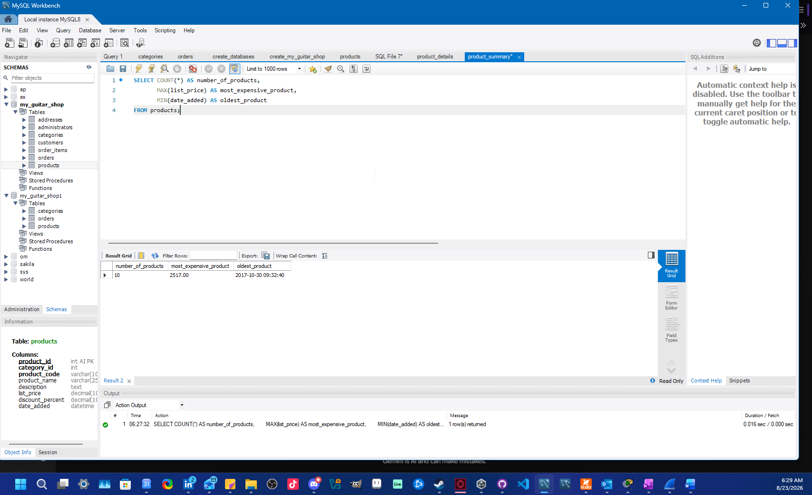
Task 4.6 - product_statements.sql Execution
